

**Introduction**

This competition will be a new concept. We are looking for Skilled Flairbartenders, routines with clean flair, the best cocktail all with high energy and a high level of entertainment. We are trying to create a concept of competition not just for flair fans but also that the general public can enjoy. This will allow all competitors to gain grand exposure as professional bartenders.

Previous Champions

1st Edition 2015 - Champion Yonny Aguilar (Péru)

2nd Edition 2016 - Marek Posluszny (Poland)

3rd Edition 2017 - ???

Facebook follow us: skilled flairbartender cancun

Hashtags: #sfbdavincicancun

[www.cancunskilledflairbartender.com](http://www.cancunskilledflairbartender.com)

Facebook: https://www.facebook.com/worldflairassociation?fref=ts

Twitter: WFLAIRA

Hashtags: #wfagrandslam

**Punctuality**

* 1. All bartenders are required to register for the competition on **16 August 11:00am** at the **T.G.I FRIDAYS CUMBRES.**
  2. All bartenders are required to attend the briefing which is going to be at on **16th August at 5:00PM.**
  3. ALL competitors must be on time for the registration, briefing and Prize Giving. Any late arrivals will be penalised.

**Registration & Payment**

* 1. All participants must register for their entry at [www.cancunskilledflairbartender.com](http://www.cancunskilledflairbartender.com) or email: [sfbinfor@gmail.com](mailto:sfbinfor@gmail.com). PLEASE SEND YOUR RECIPES IN WITH YOUR REGISTRATION! Latest date for recipes is **30th June!**
  2. Participation fee is **$85.00** if you pay before the day of the competition and **$100.00** on the day of the competition. This includes:
     1. (Welcome snacks, competition t-shirt & inscription, airport to hotel transportation).
  3. Payment for registration must be made via Western Union or Paypal, More info on the last page.
  4. All bartenders need to send us the email of their itinerary of arrival to Cancun. Flight number, time and day, for the driver to pick up at the airport.
  5. All competing bartenders as well as their supporters must be at least 18 years of age.

**Drinks & Sponsors**

* 1. The main sponsor of this event is **Da Vinci Gourmet, Island Oasis and Red Bull**
  2. In the qualification round the bartenders have to make
     1. **One Cocktail of their own Creation**
     2. **One long drink that must contain Red Bull**
  3. The cocktails must be the same for the qualifier & final round for all competitors.
  4. All available flavours from sponsors is listed below
  5. REAL ALCOHOL WILL BE USED!! NO WATER!
  6. In **the finals** bartenders have to make **same cocktails of qualification** Bartenders are allowed to use both working and exhibition flair techniques in any order for making both cocktails
  7. **In both the qualification round and final round the 10% rule will be in effect for Da Vinci Syrups (This does not include bottles with labels removed!). Bartenders will have to flair:**
     1. **24 seconds in the qualification round**
     2. **42 seconds in the final round**
  8. **All RECIPES must be sent on PDF format by 30th June! Please use the table below to fill out all details about your cocktails.**

**Cocktail 1 -** This is the bartenders own creation.

Bartenders must use:

* + Minimum **10ml Da Vinci Syrup** (any flavour from the list below)
  + Minimum **10ml Oasis Island Mix** (any flavour from the list below)

**Cocktail 2 -** This is the bartenders own creation

Bartenders must use:

* + Minimum **10ml Da Vinci Syrup** (any flavour from the list below)
  + Minimum **20ml Red Bull** (any flavour from the list below)
  + The drink must be a long drink and presented in a **14oz TGI Gibraltar glass.** The winning cocktail will go on the TGI Fridays menus

Use this form to write all information about your drink.

1. Copy and paste this form TWICE into a new document
2. Write out all the information about your drink including correct amount, detail procedure and and other information you want to add.
3. Choose “Save As” or “Export” and choose PDF.
   1. Here is a link to help: <http://www.wikihow.com/Save-a-PDF-File>

|  |  |
| --- | --- |
| Competitor name: |  |
| *Cocktail Name:* |  |
| *INGREDIENTS:-* | Insert picture below |
|  |  |
|  |
|  |
|  |
|  |
|  |
|  |
| *Glass:* |
| *Garnish:* |
| Method: | |
| Notes: | |

**On Stage**

* 1. Each participant will have **4** minutes of show time in the qualifying round, **7** minutes of show time in the final round.
  2. Competing bartenders will not be allowed to wear logos of any companies conflicting with the sponsors of the event.
  3. There will be **competition T-shirts provided** for each participant. Participants must wear them while performing and being on the stage!
  4. All music must be in a **USB DRIVE**, with your name and what round it is for. You must verify your music at least 20 minutes before your round or before.
  5. All ingredients and equipment which is not supplied by the organisation must be supplied by the bartender
  6. The **2017 WFA scoring system** will be used which is explained in detail below.
  7. WFA gradings will be awarded. Bartenders who will finish 4th, 5th will get a purple WFA grading and those finishing in 3rd, 2nd and 1st will receive a black WFA grading. Detailed information and description of WFA gradings can be found here <https://www.worldflairassociation.com/gradings/>
  8. **ONLY two bar backs** are allowed on stage at any time for each competitor. NO EXCEPTION! No one else will be allowed on stage during the competition.
  9. Any acts that display low integrity, poor taste or disrespect for the competition, sponsors or the host facility are subject to disqualification from the competition.
  10. If during the first 30 seconds of your routine your music fails, skips or stops working, you will be able to stop and start again. If it happens after 30 seconds, the DJ will attempt to continue playing your music or play something different.
  11. No fire allowed.

**Station Setup**

* 1. **We will be using two bars for the qualification round. You will be able to setup your bar while the other bartender is on stage. When the bartender has finished their round, the bar will be moved off stage immediately and the next competitor will have their bar put in place. They will then have 2 minutes to do the final preparations before they start their round.**
  2. All bottles used in the working flair must be set in at least half full. Bottles will be checked by the judges!
  3. All bottles used in the exhibition flair must be set in at least 15ml (1/2oz) of liquid. Bottles will be checked by the judges!
  4. All competitors choice bottles except **Da Vinci Syrups** must have ALL LABELS taken off and replaced with the competition stickers (the metal ring around the neck can stay on or off. It is your preference). ONLY **WFA Grand Slam stickers** or **Skilled Flairbartender Cancun** stickers are allowed.
  5. Only insulation/electrical tapecan be used on your bottles. NO EXCEPTIONS.
  6. Only 4 strips of tape will be allowed on your bottles.
  7. No empty bottles can be included in the competition bar set up.
  8. A metal pour spout is required on the working flair bottles. Tapping (this means hitting in the pour spout to make it shorter) in pour spouts is NOT allowed!
  9. Any free flowing pour spout can be used on all exhibition flair bottles. Pour spouts can taped (using electrical tape only) in place, as long as they are not restricting the flow of liquid.
  10. All the competitors’ choice ingredients for the cocktail (including garnishes) must be provided by the competitors themselves.
  11. There will be no bar tending tools provided, please bring your own bar tending equipment in order to prevent disappointment and failure.
  12. Bartenders can set up the **Flairco Portable Bar** portable bar station *(see the picture in the appendix 1)* any way they choose, but it is highly recommended that nothing starts on the upper bar surface to help with visibility for both the audience and the judges.
  13. The Top **10 professionals 2 semi-pro 2 female** from qualifying advances to the Finals. The points from qualification are not added up.

**Rules & Scoring**

* 1. The WFA Scoring system will be used in both qualification round and finals. You can find the details here: <https://www.worldflairassociation.com/wfa/competitions/wfa-scoring-system/>
  2. The competitors code of conduct must be followed and honoured throughout the whole event!
  3. Scores do not carry over from qualification round to the final.

**Other**

* 1. All rules and guidelines are subject to change at the discretion of the competition organisers.
  2. Any violation of these rules may result in penalty or even disqualification from the competition.
  3. There are 2 practice areas.
     1. **Practice space 1** is for the next 10 bartenders to go on stage
     2. **Practice space 2** is for the following 15 bartenders that are to go on stage.
     3. Please be respectful of each other and share the space.
  4. **Each bartender will receive 2 empty bottles of Da Vinci Syrup for use in the practice area. These bottles are not to be used on stage.**

**Own recipe rules & guidelines.**

* 1. Each bartender has to make 2 cocktails.
  2. **ALL RECIPES MUST BE SENT TO THE ORGANISATION BY 30TH JUNE AT THE LATEST.**
  3. Both cocktails are to be prepared on the stage during the performance.
  4. At least 2 of the ingredients used in “**Cocktail 1”** has to be a product from **Da Vinci Gourmet – Island Oasis Mix (check the example cocktails) -** This cocktail is the only one that will count towards you final score!
  5. At least 2 of the ingredients used in **“Cocktail 2”** must be **Da Vinci Gourmet & Red Bull.** This cocktail will be judged separately and will not count towards your final score.
  6. Check the product range (for details see appendix), regarding the other ingredients – you are free to use any product available in market all over the world.
  7. Garnishes must be edible and readily available in most bars.
  8. Recipes must be expressed in **millilitres, ounces or centilitres.**
  9. It is allowed to use any method (build, stir, blend, shake, and muddle etc) for cocktail preparation.
  10. Pre-mixed ingredients are not allowed. It is necessary to make the drink on the stage from the ingredients indicated in the recipe. Judges will check ALL competitors and their bottles on stage.
  11. All the ingredients and garnishes, except sponsor products from the list are participants’ responsibility. Please note that organisers will provide only those products mentioned in the list.
  12. All the preparation has to be done in the practice area, and there is no time limit.
  13. The organisers will supply a limited amount of basic glassware (see appendix for more details). Participants are encouraged to be as creative as possible and to use their own glassware for **“Cocktail 1”**. **“Cocktail 2 must be made in a 14oz Gibraltar glass supplied by the organisers”**
  14. The maximum score for the cocktail is 60 points and it is divided in 4 subcategories as explained below.
  15. There are going to be two professional tasting judges invited to give their marks for the drink creations on stage. These people will be chosen for their professionalism and experience in mixology events all over the globe. Each bartender’s score will be the average from these tasting judges. The tasting panel will be open (judges will see the bartenders performing).
  16. For the alcoholic ingredients (except sponsors) the bartenders are allowed to use any glass bottle available in the world and as many different glass bottles as needed (Your bottles don’t have to contain the original alcohol that it came with, for example, it is allowed to put gin in a rum bottle and so on). ALL LABELS taken off and replaced with the competition stickers (the metal ring around the neck can stay on or off. It is your preference). ONLY **WFA Grand Slam** stickers or **Skill Flairbartender Cancun** stickers are allowed.
  17. Juices have to be in store & pours, squeezers or any other container that is used for everyday work behind the bar without having any branded labels on it (1 L paper packs or similar packaging shouldn’t be used).
  18. All the other ingredients have to have their labels off. Or covered if it is impossible.
  19. Organisers will provide both crushed and cubed ice.
  20. Drinks recipes are to be send by email **[sfbinfor@gmail.com](mailto:sfbinfor@gmail.com)** with your registration.
  21. It is prohibited to use large knifes, scissors, fire or any materials that can cause an accident to a competitor or guests.
  22. Only the next 15 competitors can enter the practice area for warming up.
  23. Same goes for sponsor product. We will provide the products for the next 5 bartenders on stage so you have plenty of time to get them ready for the stage.
  24. There will be no friends, family, etc (without prior permission) allowed into the entertainment zone.
  25. Those with special permission will be required to wear a badge.

**Schedule:**

* 14th & 15th August - Tomek Malek Masterclass
* 16th August @ 17:00 - Meet and Greet (welcome cocktail and snacks)
* 17th August - Free Day
* 18th August @ 11:00 - Qualification Round: T.G.I. Fridays Cumbres
* 19th August @ 20:00 - Grand Final: T.G.I. Fridays Cumbres
* 21st & 22nd - Marek Posluszny Masterclass

**Venue**

**Official headquarters T.G.I Fridays Cumbres, located at Av. Luis Donaldo Colosio Plaza La Roca Cancún.**

**Prize Money - Total: $5,450**

1st - $2,500 WFA Black Level shaker Trophy Wildcard to TFBC 8

2nd – $1,300 WFA Black Level shaker Trophy

3rd – $800 WFA Black Level shaker Trophy

4th – $200 WFA Purple Level shaker Trophy

5th – $100 WFA Purple Level shaker Trophy

- 1st Semi-pro – $200 + Trophy

- Best Female – $100 + Diploma

- Best Cocktail – $150

- Best Red Bull Cocktail – $100

**WFA COMPETITOR CODE OF CONDUCT**

As a competitor in any WFA Grand Slam competition you are required to behave with respect and decorum throughout the entirety of the competition. Sponsors pay a lot of money to give us the opportunity to have these great events all over the world, so let’s treat them with respect so that they will want to repeat the competition the next year

**Dress Code**

During the competition you are required to dress accordingly to what is expected of you. In some cases you will have to wear the t-shirt provided by the sponsor on stage. In this case, make sure that it is clean and ironed and not all messy when on go on stage with it. If you require another t-shirt ask the organising staff to provide you with one

You should treat the stage like you would any bar. So no open toe shoes, like flip flops or sandals, but trainers or shoes is fine.

You are NOT allowed to wear shorts on stage. Even if it is an outside competition in the sun They look messy and unprofessional

Please make sure your trousers are clean and tidy and not covered in rips and tears.

In some cases you may want to wear a costume. This is fine, but nothing vulgar.

No nudity of any kind is allowed during your performance.

If the organiser, judge or sponsors are not happy with the way you have presented yourself you will be asked to change, incur a deduction (-5 miscellaneous) or get disqualified from the competition.

**Behaviour**

Competitions can be stressful times and everyone wants to do their best, but remember everyone is in the same boat so remember to treat EVERYONE with respect. Including the staff.

The competition staffs are there to help you. If you are rude or arrogant towards them, you may face disqualification, or refusal to enter the next Grand Slam competition.

Any rudeness or disrespect towards other competitors can face disqualification. This can be at anytime throughout the competition, in the practice area, on stage or where ever.

Try and help out other competitors whenever you can.

The judges have a difficult decision and are always willing to answer your questions after a competition, but any rudeness or disrespect towards them could mean refusal to enter the next Grand Slam competition.

**Announcements**

This is a big moment for everyone, whether it is announcing the finalists or the overall winners. Everyone is nervous and everyone wants to win. If you are not happy with your placement, DO NOT walk off stage in a huff. Collect your prize and wait for the all clear to get off the stage once all announcements are finished. Failure to do so can result in disqualification or being banned from the next Grand Slam comp.

When it comes to announcements please wear either the competition t-shirt or your sponsor or representation’s attire. Each competition is different and you will be briefed by the organisers. We do not want to see you in your shirt ready for a night out.

It is also NOT allowed to be drunk when you are on stage collecting your prizes, and we do NOT want to see you with a drink in your hand on stage. Failure to follow these guidelines can mean you not receiving your prize and or being disqualified from the competition.

**Bottles to be used**

As we have mentioned before the sponsor pay a lot of money to put on these competitions so they want to see their bottles used at competitions as much as possible. Anyone thought to be blatantly disregarding the sponsors bottles will be disqualified from the comp or incur a major deduction

**Music**

This will always be down to the organiser as to when they want your music. Please make sure it is clearly labelled and is only on ONE CD or USB depending on what the organisers ask for.

**After the competition**

Once the competition is over you have the chance to chat with the judges and discuss your scores on how you can improve for the next comp.

Any discrepancies’ in the scores should be put in writing to the World Flair Association, sent to [info@worldflairassociation.com](mailto:info@worldflairassociation.com) or [sfbinfor@gmail.com](mailto:sfbinfor@gmail.com) by the individual who is not happy.

The World Flair Association will try and solve any problems with scores or results in any way they can.

**Overall**

Any competitor not respecting the rules of the competition, the judges, fellow competitors or the sponsors can face disqualification from the competition or be banned from the next Grand Slam competition.

**Appendix 1 “PORTABLE BAR”**

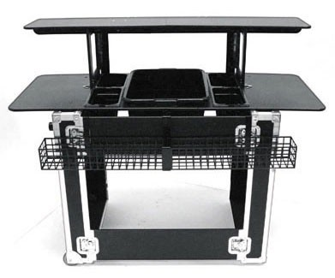

The bar itself measures 31" x 10" x 25" when packed into the road case that is also the base of the bar. When assembled, the bar is strong enough to support the weight of a grown man on top of the base sides (over 200 pounds). The main bar top measures approximately 56" x 22" while the upper bar top measures 54" x 12". The ice well is a full size bus bin with additional inserts for another eight juice containers, bottles, or any extra supplies. The metal speed rail fits eleven 750mL bottles or ten 1L bottles and is very sturd

|  |  |  |
| --- | --- | --- |
| DA VINCI SYRUPS FLAVOURS CLASSIC | ISLAND OASIS MIXES | RED BULL FLAVOURS |
| ALMOND | SOUR MIX | CLASSIC RED BULL |
| AMARRETO | PAPAYA | SUGAR FREE |
| CINNAMON | MARACUYA | RED EDIT (CRANBERRY) |
| CARAMEL | ICE CREAM | BLUE EDIT (BLUEBERRY) |
| WHITE CHOCOLATE | MANGO | LIME EDIT(LIME-LEMON |
| DARK CHOCOLATE | GUAVA | (PINEAPPLE-FRUIT PASSION) |
| COCONUT |  | |
| IRISH CREAM |  | |
| MINT |  | |
| EGG SYRUP |  | |
| VANILLA |  | |
| RED VELVET |  | |
| CHEESE CAKE |  | |
| CHERRY |  | |
| BLACKBERRY |  | |
| BLUE CURACAO |  | |
| FRUIT PASSION |  | |
| HABANERO PEPPER |  | |
| RASPEBERRY |  | |
| CHOCO MINT |  | |
| BANANA |  | |
| MANDARIN ORANGE |  | |
| STRAWBERRY |  | |
| GREEN APPLE |  | |
| WATERMELON |  | |

**Appendix 2 “ SPONSOR´S PRODUCTS AVAILABLE”**

**Appendix 3 Glassware supplied by organisers**

**Only**

* Official glass Giblatar 14oz

just for Red Bull cocktails.

* Napkins Holders

If you need some products, all the bartenders are advise to buy desired products one day before the competition.

HOTELS AVAILABLE

ALL RESERVATIONS OR INFORMATION TO:

[SFBINFOR@GMAIL.COM](mailto:SFBINFOR@GMAIL.COM) OR SKILLED FLAIRBARTENDER

Special Prices for room

|  |  |
| --- | --- |
| Double room 2 pax | Room 4 pax |
| $ 68.00 usd | $ 95.00 usd |
| $ 85.00 usd w/breakfast | $ 130.00 usd  w/ breakfast |

[www.adharacancun.com](http://www.adharacancun.com)

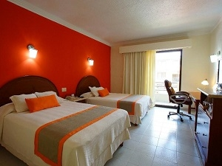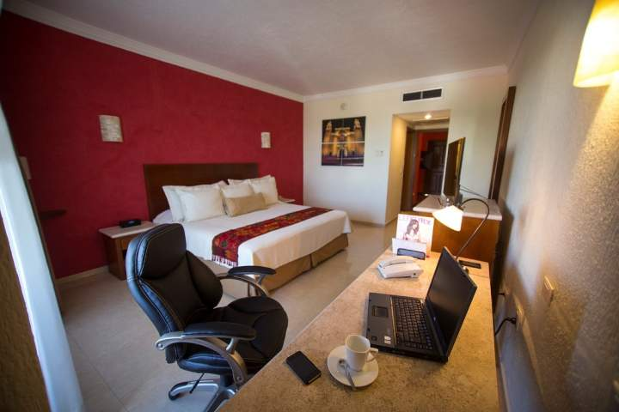

 Included: Room Double bed or King size

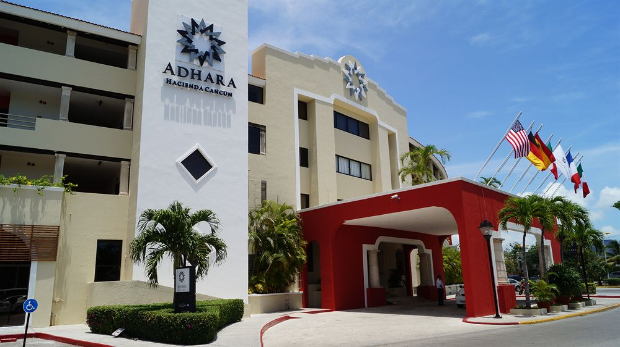 Taxes

Tips for bellboy and house keeping

A/c, Tv Cable

Pool and Gym

Wifi internet free

|  |  |
| --- | --- |
| Double room 2 pax | Room 4 pax |
| $ 60.00 usd | $ 80.00 usd |
| $ 75.00 usd w/breakfast | $ 110.00 usd  w/ breakfast |

Transportation Airport to hotel

[www.ramadacancun.com](http://www.ramadacancun.com)

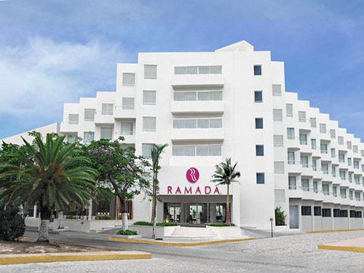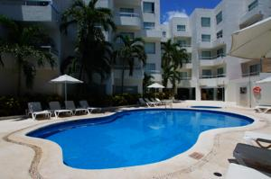

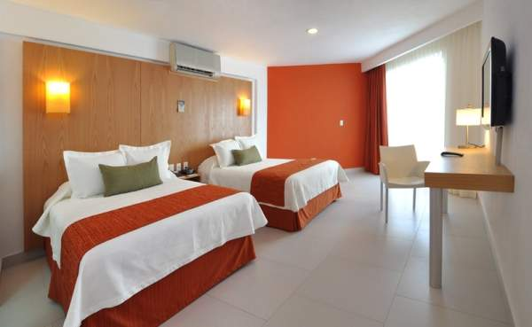 Included: Room Double bed or King size

Taxes

Tips for bellboy and house keeping

A/c, Tv Cable

Pool and Gym

Wifi internet free

Transportation Airport to hotel

|  |  |
| --- | --- |
| Double room 2 pax | Room 4 pax |
| $ 47.00 usd | $ 70.00 usd |
| $ 60.00 usd w/breakfast | $ 90.00 usd  w/ breakfast |

[www.hotelmargaritascancun.com](http://www.hotelmargaritascancun.com)

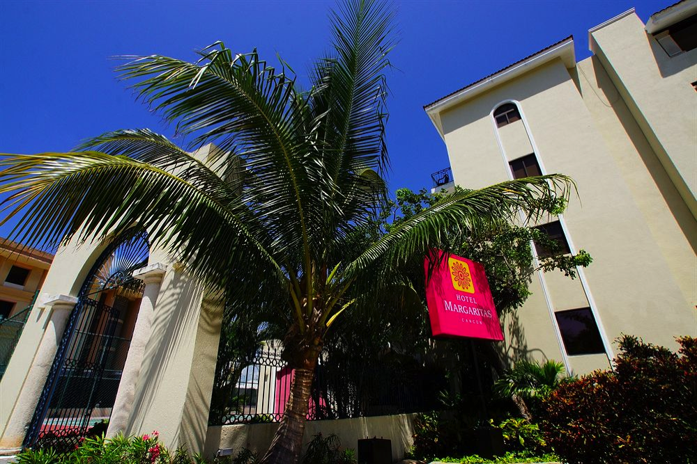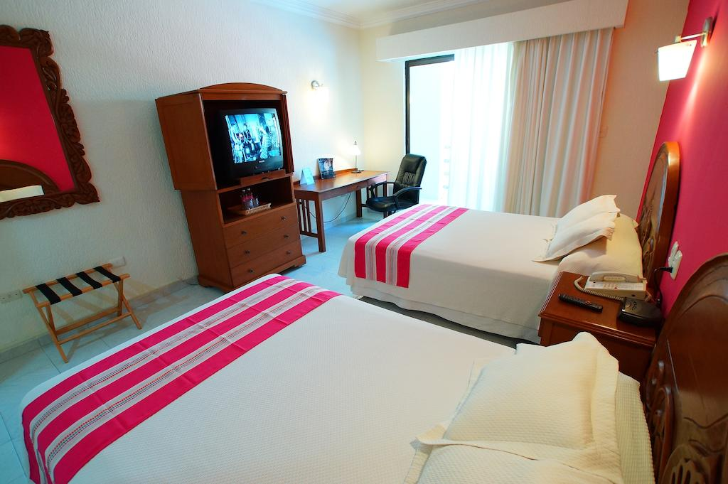

Included: Room Double bed or King size

Taxes

Tips for bellboy and house keeping

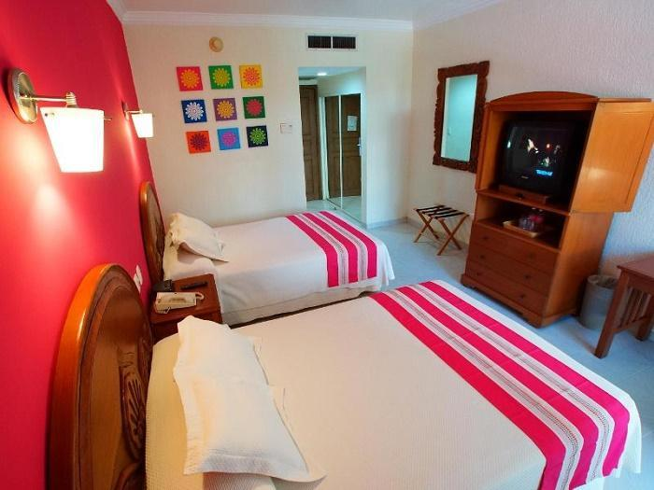 A/c, Tv Cable

Wifi internet free- transportation to hotel

VENUE



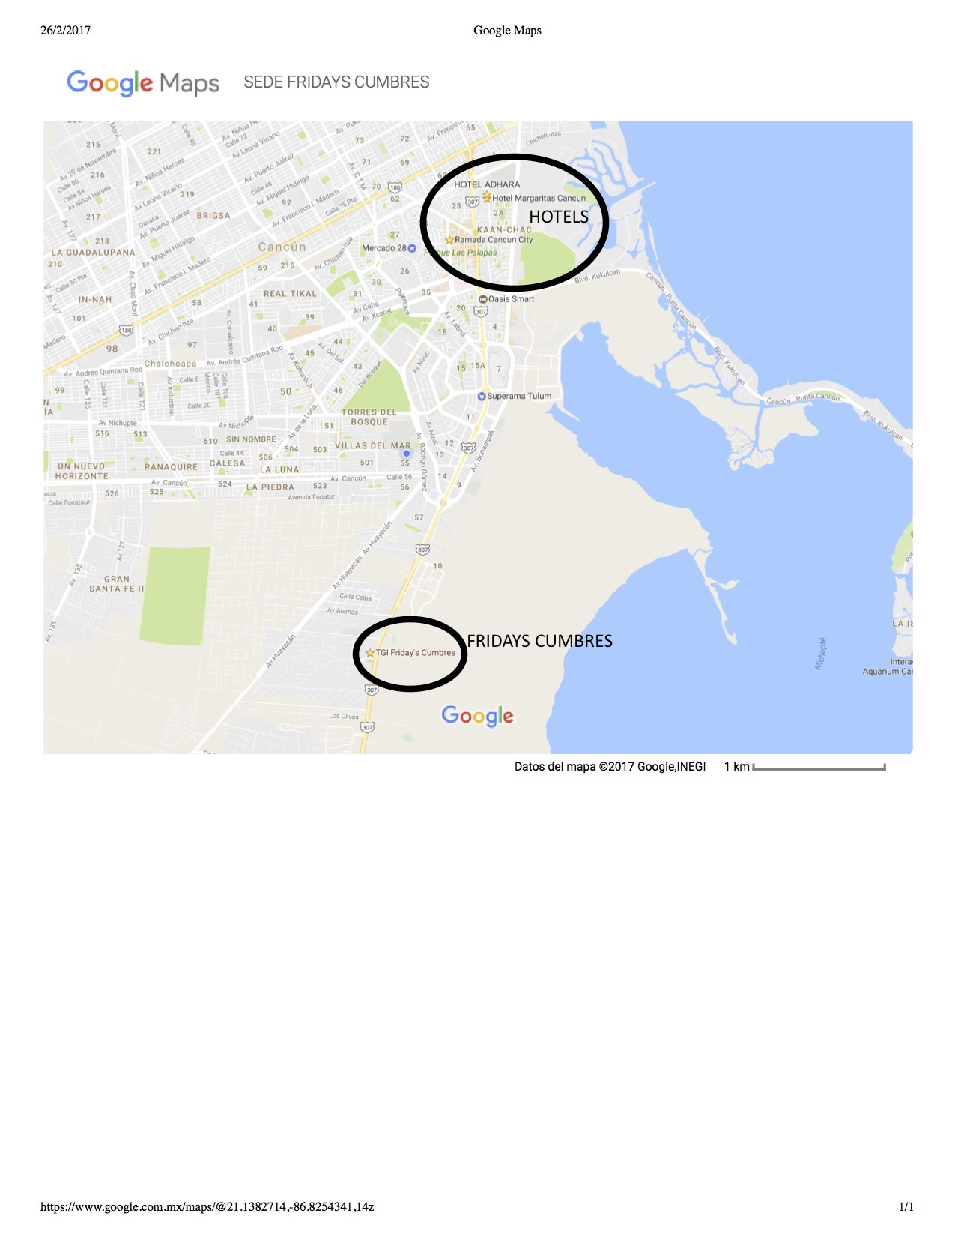

TAXY AIRPORT TO CENTER EXPENSIVE. 40 USD OR 50 SOMETIMES OR MORE.

WE HAVE FREE TRANSPORTATION IF YOU HAVE A HOTEL, AIRPORT TO HOTEL,

IF YOU WANT TRANSPORTATION HOTEL TO AIRPORT 10 USD EXTRA , ANYTIME YOU NEED RESERVATION.

**PAYMENTS**

**Option 1 ( Mexican bartenders)**

**FOR TRANSFER BANK – PARA DEPOSITO DE PAGO EN:**

**BANORTE BANK TRANSFER**

**HERBERTH PAUL HEREDIA**

1 usd is 21.00 mexican pesos

Cuenta: 0231518406

Clabe Inter: 072691002315184069

**DEPOSITO EN TIENDAS EXTRA O BANORTE**

4915-6620-7862-1383

**Option 2**

**FOR FORGIENERS USD **

[www.cancunskilledflairbartender.com](http://www.cancunskilledflairbartender.com)



[masterbartender@icloud.com](mailto:masterbartender@icloud.com)

or



Name: Herberth Paul Heredia Salazar

Country: MEXICO

Cel: 9985771155

For registration send the receipt.

INFORMATION HERE:

[SFBINFOR@GMAIL.COM](mailto:SFBINFOR@GMAIL.COM) O CEL: 9985771155